Final Project Report

Skip The Agent



Project Supervisor
Muhammad Zubair Nawaz

Submitted By

F2102448D2

Afraz Malik BC180403635

Software Projects & Research Section,
Department of Computer Sciences,
Virtual University of Pakistan


CERTIFICATE

This is to certify that Afraz Malik (Bc180403635) has worked on and completed their Software Project at Software & Research Projects Section, Department of Computer Sciences, Virtual University of Pakistan in partial fulfillment of the requirement for the degree of BS in Computer Sciences under my guidance and supervision.

In our opinion, it is satisfactory and up to the mark and therefore fulfills the requirements of BS in Computer Sciences.

Supervisor / Internal Examiner

Muhammad Zubair Nawaz,
Supervisor,
Software Projects & Research Section,
Department of Computer Sciences
Virtual University of Pakistan

___________________
(Signature)

External Examiner/Subject Specialist
<<External Supervisor Name>>

___________________
(Signature)

Accepted By:

_____________
(For office use)

EXORDIUM

In the name of Allah, the Compassionate, the Merciful.

Praise be to Allah, Lord of Creation,
The Compassionate, the Merciful,
King of Judgment-day!

You alone we worship, and to You alone we pray for help,
Guide us to the straight path

The path of those who You have favored,

Not of those who have incurred Your wrath,
Nor of those who have gone astray.

DEDICATION

It is with genuine gratitude and warm regard that I dedicate this project to open source platform where anyone can get it and learn the way I put my efforts on it through different tools.

ACKNOWLEDGEMENT

I am grateful to Almighty God for giving me the strength, knowledge and understanding to complete this project. His love has been more than sufficient to keep and sustain me.

My profound gratitude goes to my wonderful supervisor, Muhammad Zubair Nawaz for his invaluable support, patience, time and guidance in seeing me to the completion of this project.

I also extend gratitude and appreciation to my lecturer, who has taught me at one point or the other. May God continue to bless, protect, and guide you all!

God bless you all
PREFACE

In this project I have presented a platform to buy and sell used cars directly around globe by skipping the agent and their fees.

~The Author
TABLE OF CONTENTS

CHAPTER NO. 1
gathering & Analyzing info 9

1.1 Introduction

1.2 purpose

1.3 scope

1.4 definitions, acronyms and abbreviations

1.5 Project requirements

1.5.1 Functional Requirements

1.5.2 Non-Functional Requirements

1.6 use cases and usage scenarios

1.6.1 Use Case Diagrams

1.6.2 Usage Scenarios

1.7 Development Methodology

1.7.1 Chosen Methodology

1.7.2 Reasons for Chosen Methodology
1.7.3 Work Plan (Gantt Chart)
1.7.4 Project Schedule (Submission Calendar)

CHAPTER NO. 2
designing the project 12

2.1 Introduction

2.2 Purpose

2.3 Scope

2.4 Definitions, acronyms and abbreviations

2.5 Architectural Representation (Architecture Diagram)

2.6 Dynamic Model: Sequence Diagrams

2.7 Object Model/Logical Model: Class Diagram

2.8 Database Model (Database Diagram)

2.9 Graphical User Interfaces

Chapter no.3
DEvelopment 13
3.1 Development plan (Architecture Diagram)

CHAPTER 1
Gathering & Analyzing Info

  - Introduction

A platform to buy/sell used cars without any agent and their heavily fees’. A platform where we can get the dream car at low rates by seeing every minor details of the car through user-friendly UX/UI.
  - Purpose

The main purpose of this project is to get people more aware to skipping the agent. Whenever someone wants a used car, they go to the agent to buy it. The question is if someone is buying an old car that means he definitely needs the low rates, that’s why people should be more aware to skipping the agent and get the cars by their own.

  - Scope

In the current era, everyone loves to be updated by time in any terms with society. Vehicle is the building block of our today’s life, and we want to have the latest car as per our price. Thus, this platform helps the client thru every step of the car buying and selling process. From searching out what kind of car they would like to buy or sell, to finding the car, and helping them finance the new or used car.

As the name suggests, this platform make the buyer or seller to skip the agent and contact each other directly without any medium. They don’t have to go to agent to buy or sell cars, else they will interact with this super flexible platform where they will find every detail or their desired cars. Both buyer and seller can have communicated with each other through this platform with built in chat system.

  - Definitions, acronyms and abbreviations

- Definitions.
Finger tips: Internet as village
- Acronyms.
STP Skip The Agent
SRS Software Requirements Specification
- Abbreviations.
None.

  - Projects Requirements

    - Functional Requirements

- User (Buyer/Seller):

  - Registration and sign in: User will register him/herself in this platform in order to buy or sell their cars after verifying their email through auto mail verification service.
  - Sell Car: Seller must register themselves to post an ad for car selling. After signing in, seller will be able to post ad of their used cars by filling an actual car parts form where they must enter details of their car.
  - Listing: Seller will be able to view the status (active, pending, removed) of their active ads.
  - Alerts: User can create alert for specific cars and user will be alerted thru email if this cars registers in this system.
  - Chat System: This platform will provide chat system for user, where both buyer and seller can chat in order to start their order or buying/purchasing car. (Message will be end-to-end private by encryption and cannot be by admin as well, thus privacy is important factor).

- Admin
  - Manage Ads: Admin can view ads of all cars which is available for selling and can remove or ban the ad.
  - Manage Users: Admin can view or block users

- Visitor

  - Faculty List: Ads Listing: All the active ads of cars will be visible for visitor, where they will be applying searches for their desired cars. They don’t have to get registered in order to view ad. Buyer (visitor) can view phone number of seller and continue their order.

    - Non- Functional Requirements

- Responsive/Performance:

  - Responsive: It will be fully Responsive Web App that will provide best experience on every browser on every device.
  - Performance: App will work faster even on slow internet by using fastest algorithm.

- User Friendly
  - Interactive: App will be fully interactive and user friendly. User will interact through fully flexible and responsive GUI.
  - Easy to understand: It will provide a user interface that can be used by anyone, even if they have no deep knowledge of it. This website will have elements

- Efficiency

- The online website should ensure that it is reliable. System should be able to complete its on-going operations in spite of any error or problem within defined response time.
- The ability of our system to behave consistently in a user-acceptable manner when operating within the environment for which the system was intended. For example, our system will be able to update process must roll back all related updates in the database when any update fails.
- Maintainability:
- This Web application will be very simple and easily maintainable by adding any further features in the future allow making change easier and more affordable, avoiding change that is not necessary and should allow performing a successful repair action within a given time. Also, configuration and content management will be easy.

  - Use Cases & Usage Scenario

    - Use Case Diagram

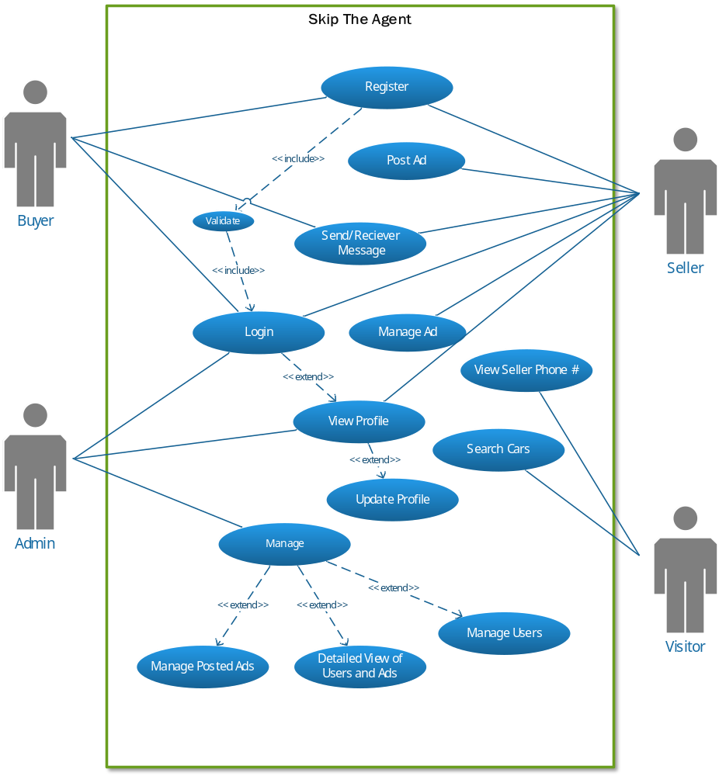

    - Usage Scenarios

Use Case Title | Search Used Cars
Use Case Id | 1
Actions | Visitor will see used car details on website using different filters
Descriptions | This Use Case will allow the visitor to search for the cars that has been added into the website by seller. Visitor can search the car using different filters such as by their name, brand, engines, specifications and can view car details like price, name brand engine types and much more.
Alternative Paths | None
Pre-conditions | - System should be connected with the database.  - Application should be running properly.  - There must be at least One Faculty Member’s info
Post-conditions | - Visitor has searched the cars successfully
Author | F2102448D2 (BC180403635)
Exceptions | None

Use Case Title | Registration
Use Case Id | 2
Actions | Register to this website database
Descriptions | This Use Case will allow the users to register themselves in order to post an ad for selling or to chat with other users. User will have to fill a form containing all the necessary information which is needed to complete the registration process.
Alternative Paths | None
Pre-conditions | - System should be connected with the database.  - Application should be running properly.  - User has a Valid Email Address.
Post-conditions | - The Registration was successful.
Author | F2102448D2 (BC180403635)
Exceptions | None

Use Case Title | Login
Use Case Id | 3
Actions | Login to website
Descriptions | This Use Case will allow member to login into the site / system. They will have to enter his / her Email and Password to get login into the system
Alternative Paths | None
Pre-conditions | - System should be connected with the database  - Application should be running properly.  - User should have a Valid Username and Password.  - User must have registered account in the application before login  - User can sign in after the approval of admin
Post-conditions | - User logged into the system successfully.  - User re-directed to his / her profile, based on his / her role in the system.
Author | F2102448D2 (BC180403635)
Exceptions | None

Use Case Title | View Profile
Use Case Id | 4
Actions | Members can view their Profile
Descriptions | This Use Case will allow members to see their profile after they logged in to the system. User will have to click the Profile button on the top of the website in their dashboard
Alternative Paths | None
Pre-conditions | - System should be connected with the database.  - Application should be running properly.  - Member must have logged in with their credentials
Post-conditions | - Members have to click the profile element
Author | F2102448D2 (BC180403635)
Exceptions | None

Use Case Title | Update Profile
Use Case Id | 5
Actions | Members will edit the profile form showing in profile section
Descriptions | This Use Case will allow Member to edit their profile including their password. The Member will have to save the profile after editing. They must have to enter their previous password in order to change it.
Alternative Paths | None
Pre-conditions | - System should be connected with the database.  - Application should be running properly.  - Member must have logged in with their credentials
Post-conditions | - Profile Updated Successfully Popup will show up.
Author | F2102448D2 (BC180403635)
Exceptions | None

Use Case Title | Recover Password
Use Case Id | 5
Actions | User can recover the password if they forgot
Descriptions | This Use Case will allow the users to reset their password if they forgot it by using their registered email
Alternative Paths | None
Pre-conditions | - System should be connected with the database.  - Application should be running properly.  - Member must have valid email
Post-conditions | - Members has recovered password successfully.
Author | F2102448D2 (BC180403635)
Exceptions | None

Use Case Title | Post Ad
Use Case Id | 6
Actions | Member will post an ad(s) through the form that will show up in their profile
Descriptions | After the login to the system, user will be able to post an ad to sell their car after filling the information that will be shown up in the website that will be viewed by visitor/student. When faculty member will log in to the system. They will redirect to their dashboard where they can add.
Alternative Paths | None
Pre-conditions | - System should be connected with the database.  - Application should be running properly.  - Member must have logged in with their credentials
Post-conditions | - Ad posted successfully
Author | F2102448D2 (BC180403635)
Exceptions | None

Use Case Title | View / Manage their ad
Use Case Id | 7
Actions | User can see posted ads and can update as per they desire.
Descriptions | This Use Case will allow user to view their posted ad’s and which they can manage.
Alternative Paths | None
Pre-conditions | - System should be connected with the database.  - Application should be running properly.  - Member must have logged in with their credentials  - They must have to add their details first in order to update
Post-conditions | - Ad updated successfully
Author | F2102448D2 (BC180403635)
Exceptions | None

Use Case Title | Save Car ads
Use Case Id | 8
Actions | User can save car ads after registering by clicking save button
Descriptions | This Use Case will allow the user to save car ads which they can find in “Saved Ads” sections in their dashboard.
Alternative Paths | None
Pre-conditions | - System should be connected with the database.  - Application should be running properly.  - There must be at least One Faculty Member’s info
Post-conditions | - Ad Saved Successfully
Author | F2102448D2 (BC180403635)
Exceptions | None

Use Case Title | Create Alert
Use Case Id | 9
Actions | User can create alert for their desire cars
Descriptions | This Use Case will allow the user to create alert for their specific cars, they will get notified as soon the car is available for selling.
Alternative Paths | None
Pre-conditions | - System should be connected with the database.  - Application should be running properly.  - There must be at least One Faculty Member’s info
Post-conditions | - Alert created successfully
Author | F2102448D2 (BC180403635)
Exceptions | None

Use Case Title | Manage Users / Ads (Admin)
Use Case Id | 10
Actions | Admin can view, ads and users that are registered with system
Descriptions | This Use Case will allow admin to view the information as well as admin can manage them accordingly.
Alternative Paths | None
Pre-conditions | - System should be connected with the database.  - Application should be running properly.  - Admin must have logged in with their credentials  - There must be at least one faculty member’s info
Post-conditions | - Details will be update accordingly
Author | F2102448D2 (BC180403635)
Exceptions | None

  - Development Methodology

    - Chosen Methodology

According to the requirement, for making our software we adopted the methodology “VU process model”. The description of which is given below:
- VU Process Model:
It is the combination of waterfall methodology and spiral methodology. It is also known as hybrid approach of system development. It has five phases, and which are Gathering and Analyzing requirement, Planning, Analysis and Design, Development and Final report.
Essentially, Water Fall Model is a framework for software development in which development proceeds sequentially through a series of phases, starting with system requirements analysis and leading up to product release and maintenance, whereas the key characteristic of spiral model is risk management at regular stages in the entire software development cycle.

- Diagram
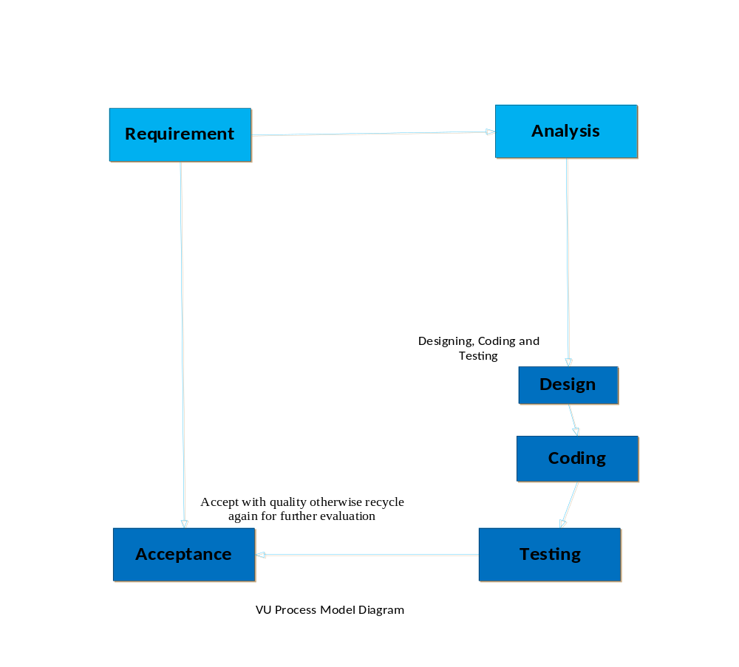
    - Reason for Chosen Methodology

Following are the basic reasons for choosing VU Process Model for our project:
- Our project is divided into different phases which we have to complete in sequence and submit it to our supervisor. In the requirement phase the system goals, services and constrains are established after discussion with user.
- The planning phase is synchronized effort to find all the potential roadblocks and draft a robust plan to tackle each. This phase usually involves a lot of brainstorming within software development team as well as with respective client. It maximizes the quality of system and minimizes any risks and errors.
- If Supervisor suggests improvement, then we will make improvement in planning phase. This process will be adopted due to the spiral nature of VU Process model. When the phase is well-improved and well worked out, and accepted by our supervisor then we will proceed to next phase. This will be done due to the waterfall nature of the VU Process model.

Hence both models are suppressed in single form and that will be our VU process model. It will provide error free result as each step is done in a sequence.

    - Work Plan (Gantt Char)

          - TimeLine
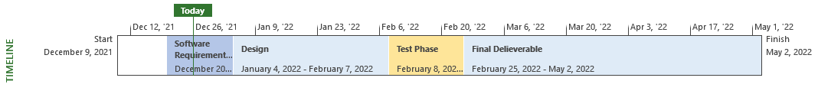
          - Gantt Chart

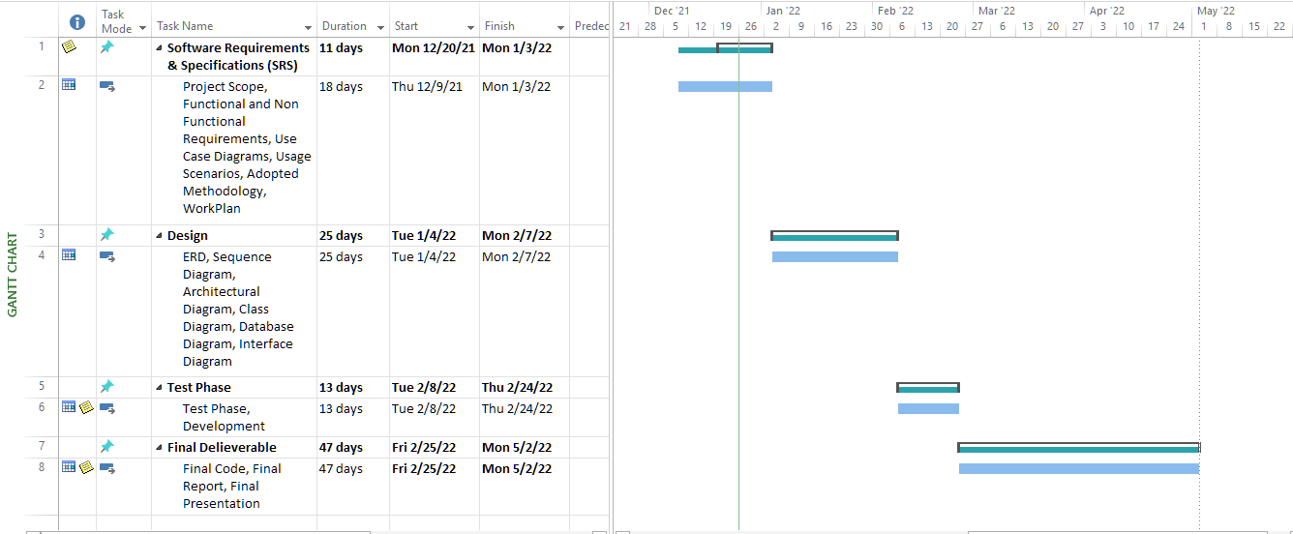

    - Project Schedule (Submission Calendar)

Sr. No. | Assignment Title | Submission Date
1 | SRS
2 | Design
3 | Test Phase
4 | Final Deliverable

CHAPTER 2
Designing the Project

  - Introduction

The project is to develop a Skip the agent, a web application; it provides great flexibility to buy and sell used cars by online.
Design documentation is a collection of documents and resources that covers all aspects of your software design. The document gives a brief account of different operations that are performed by system describe the relationship between these operations within as well as outside the system. This phase represents the “How” phase. Details on computer programming languages and environments, machines, packages, application architecture, distributed architecture layering, memory size, platform, algorithms, data structures, global type definitions, interfaces and many other engineering details are the deliverables of design phase. This document presents the designs used or intended to be used in implementing the project.
  - Purpose

The purpose of the Software Design Document is to provide a description of the design of a system fully enough to allow for software development to proceed with an understanding to be built and how it is expected to build. Design documents are also referred to as functional specifications or functional specifications documents, or functional requirements specifications

  - Scope

In the current era, everyone loves to be updated by time in any terms with society. Vehicle is the building block of our today’s life, and we want to have the latest car as per our price. Thus, this platform helps the client thru every step of the car buying and selling process. From searching out what kind of car they would like to buy or sell, to finding the car, and helping them finance the new or used car.

As the name suggests, this platform make the buyer or seller to skip the agent and contact each other directly without any medium. They don’t have to go to agent to buy or sell cars, else they will interact with this super flexible platform where they will find every detail or their desired cars. Both buyer and seller can have communicated with each other through this platform with built in chat system

  - Definitions, acronyms and abbreviations

- Definitions.
Finger tips: Internet as village
- Acronyms.
GUI Graphical User interface
SRS Software Requirements Specification
- Abbreviations.
None.

  - Architectural Representation (Architecture Diagram)

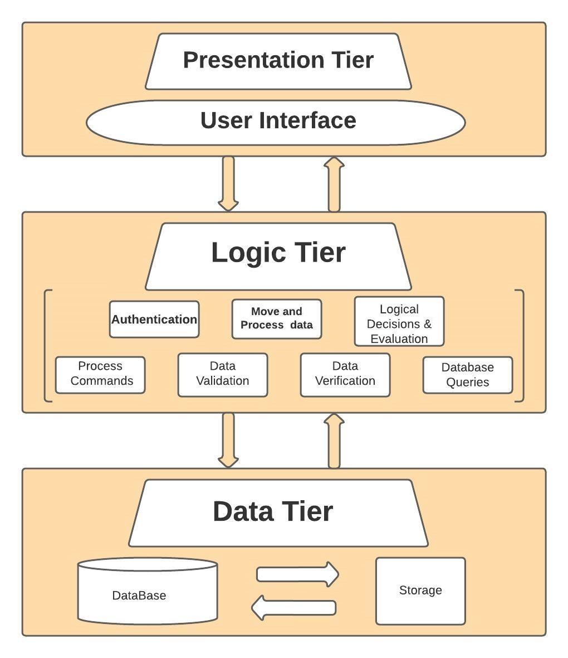

  - Dynamic Model: Sequence Diagrams

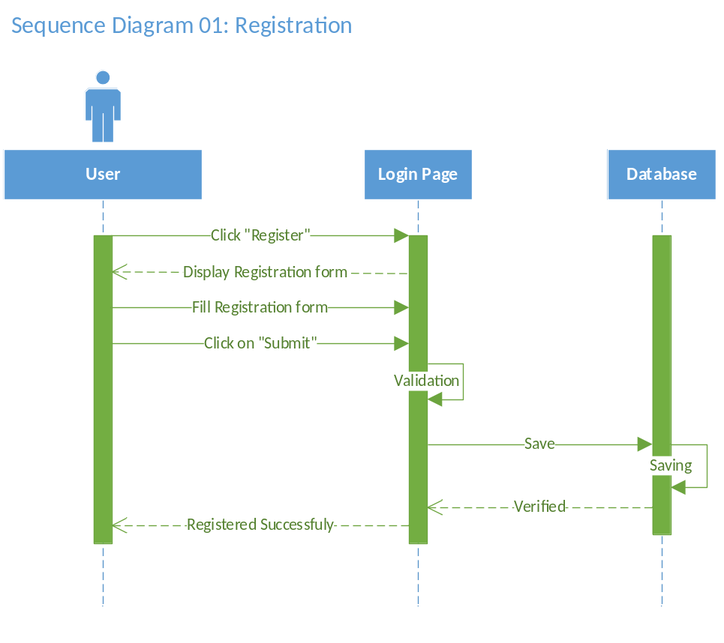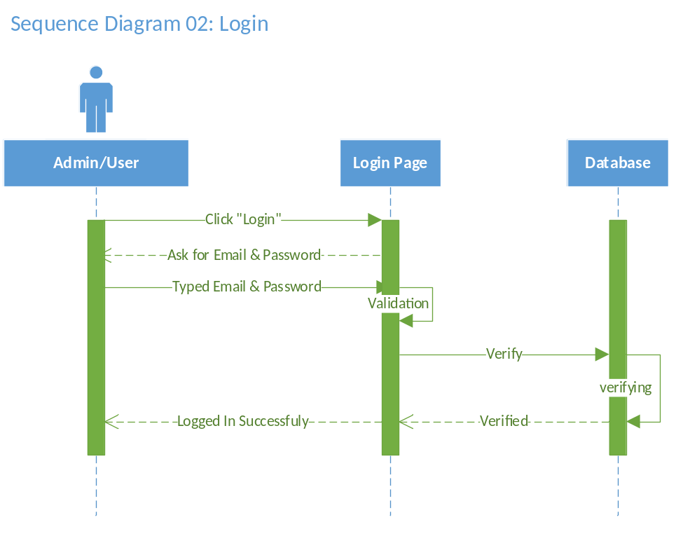
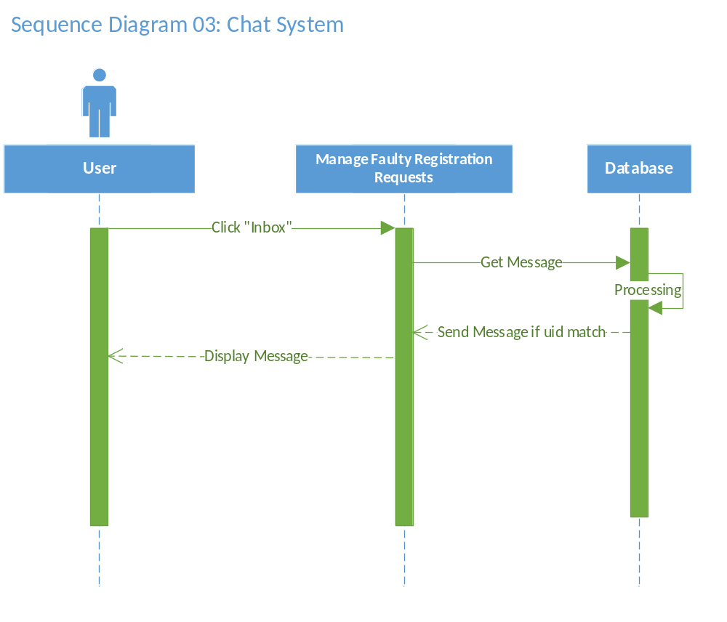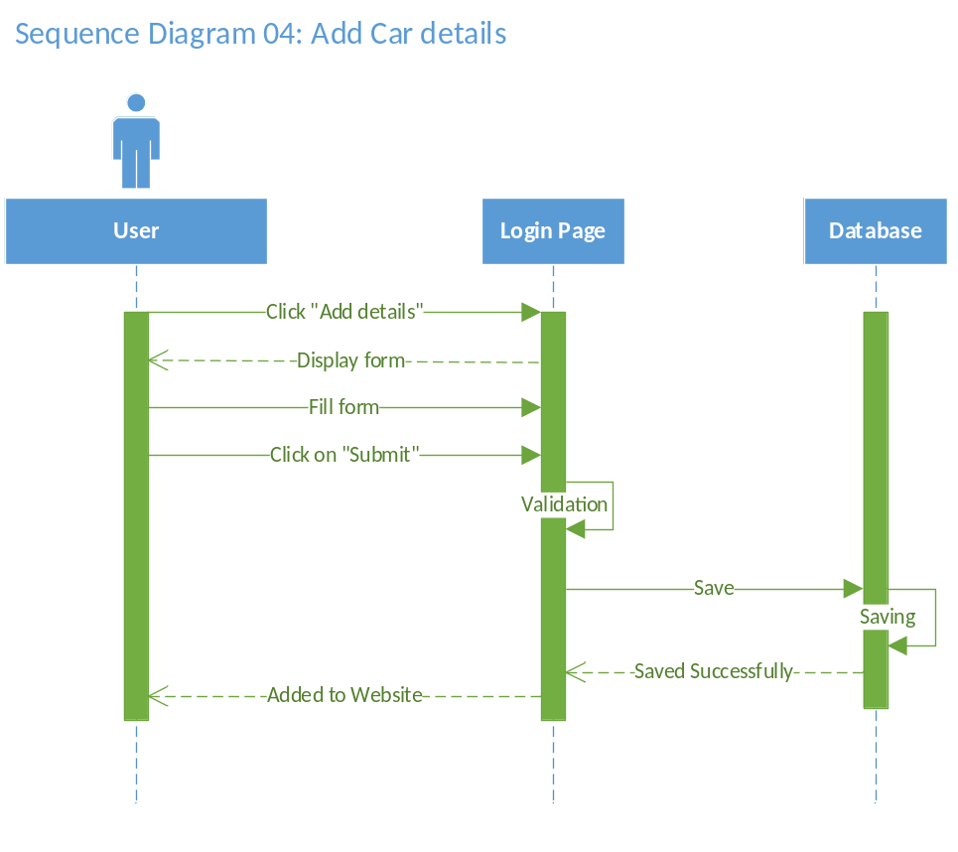
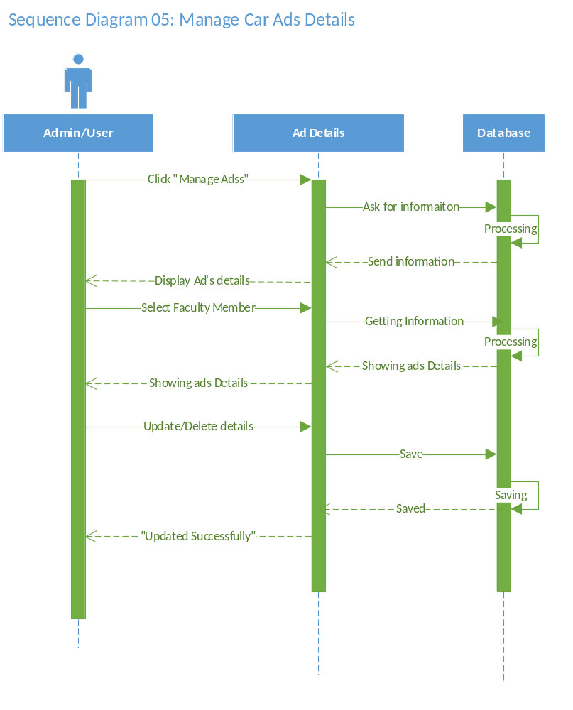
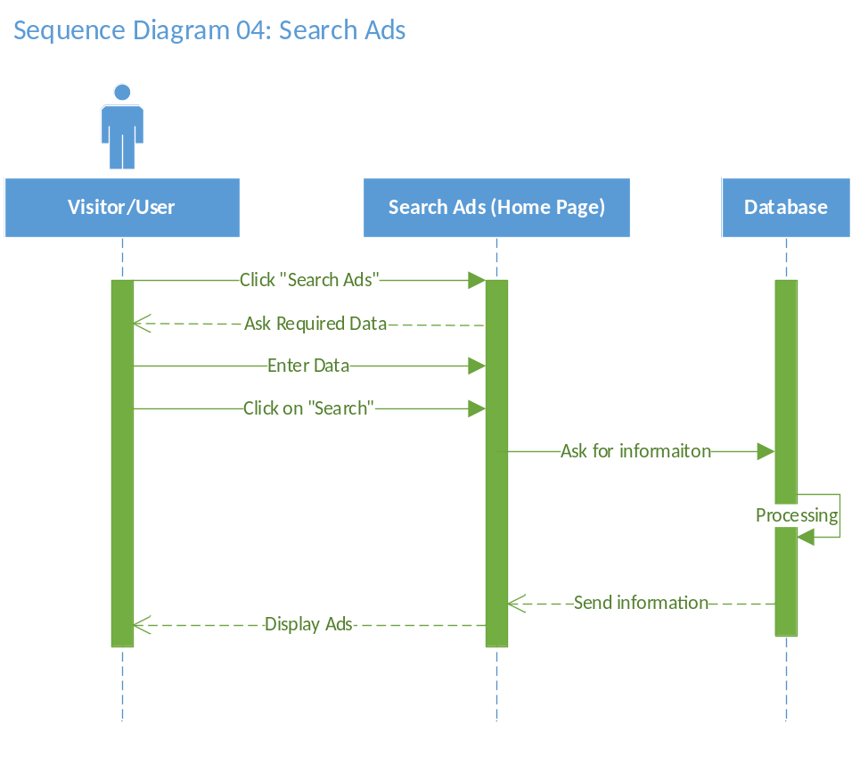

  - Object Model/Logical Model: Class Diagram

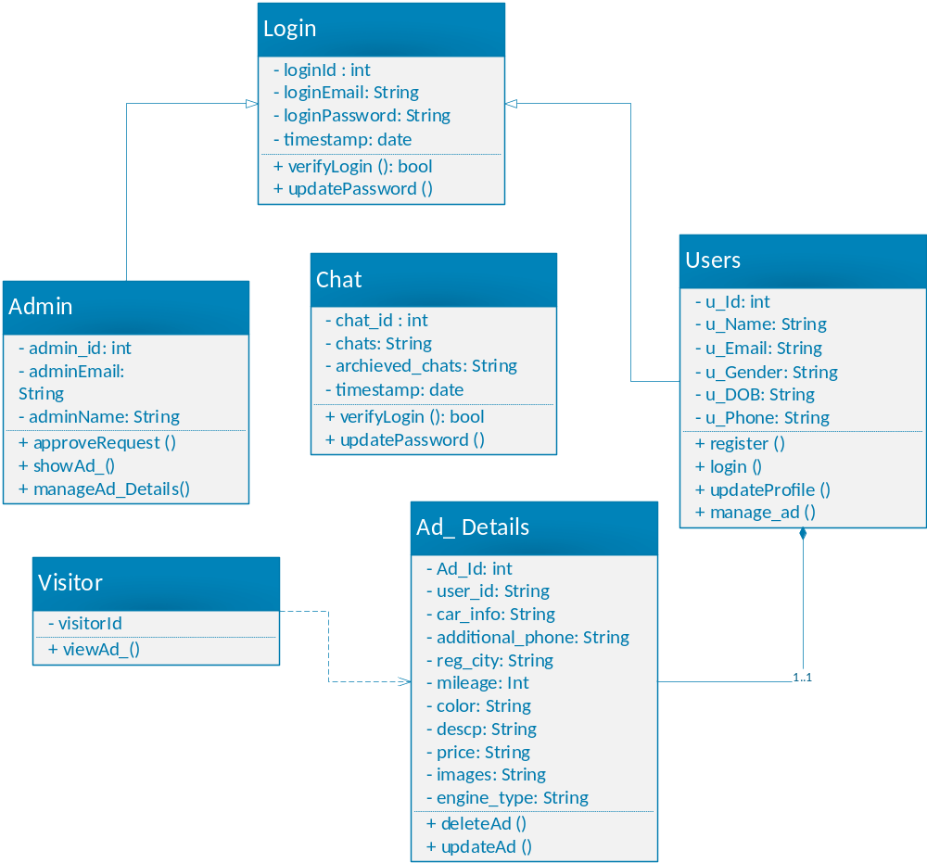

  - Database Model (Database Diagram)

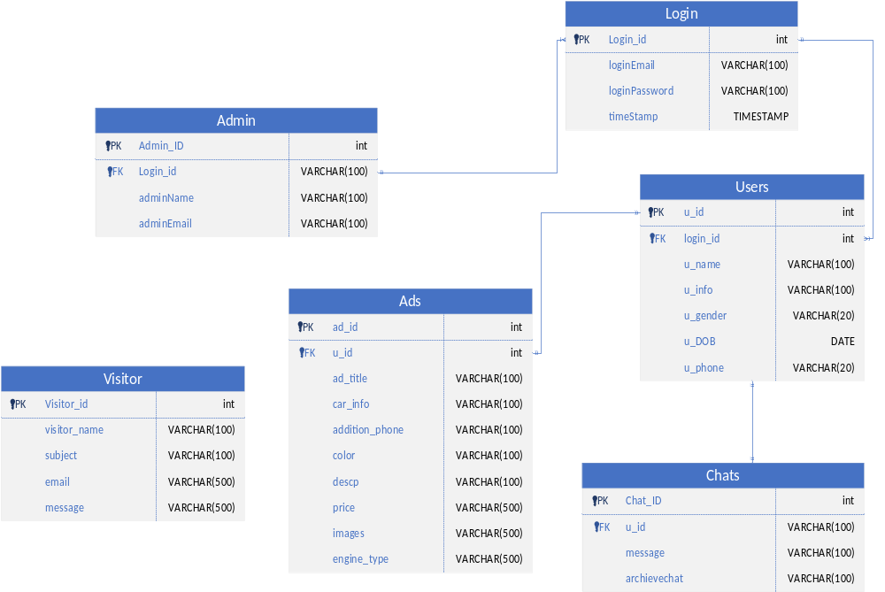

  - Graphical User Interfaces

- Home Page

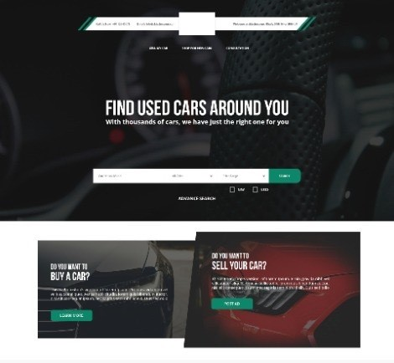
- Sign In
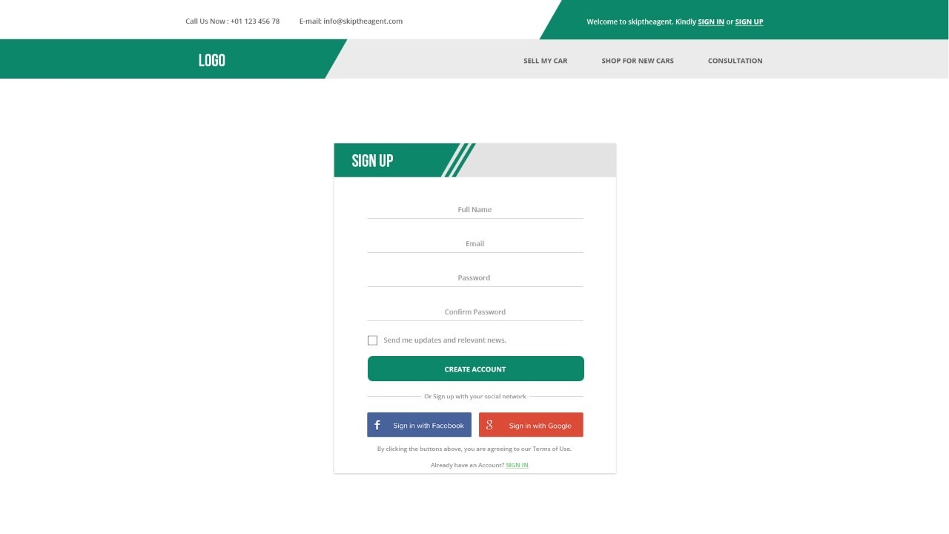

- Product details

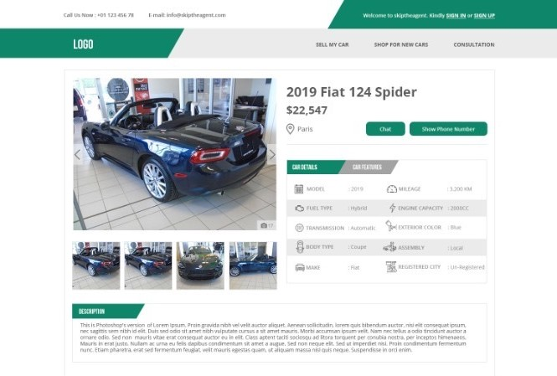

CHAPTER 3
Development

  - Development plan (Architecture Diagram)

REFERENCES

Skip the agent (2022), Final year project. Available at: https://afraz-malik.github.io/skiptheagent
Source code uploaded at https://www.github.com/afraz-malik/skiptheagent
Template designed from UX/UI designer, PSD available here
Packages available in https://www.npmjs.com/packages/redux
Database available on https://www.firebase.com/firestore/ur2d?id=2

APPENDIX

- Appendix of Chapter 1

The user friendly way of buying and selling cars.

- Appendix of Chapter 2

The graphical representation of this project

